**Ruleset & Versions:**

**What is Ruleset:**

* **Collection of Rules ( Container Which holds all the rules)**
* **Ruleset is associated with Ruleset Name & Version. We can create Different Version for a Ruleset**

**For Our Application Ruleset Name:  ALFAAUTO**

**Versioning Purpose:**

* **In New Versions: Add /Modify the functionalities**
* **Adv of Versioning : Without disturbing the old features we are adding New Features/Update the features.**
* **In PEGA Versioning Plays major role in Deployments**

**Default Version No: 01-01-01**

**1st 01 : Major Version**

**2nd 01: Minor Version**

**3rd 01 : Patch Version**

**01-01-01 (Default Version)**

**Always Version increment will be based on Patch**

**01-01-02**

**01-01-99**

**01-02-01**

**01-99-99**

**02-01-01**

**99-99-99**

**=========**

**Create a New Ruleset Version for Existing Ruleset: 01-01-02**

**From Application Menu-> Click on Definition**

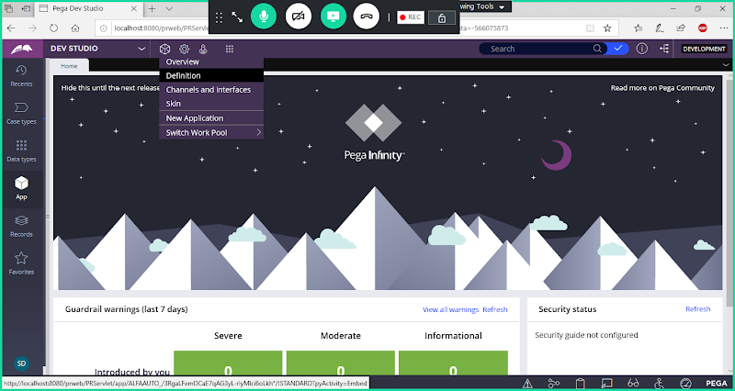

**Open the Ruleset: Click on Circle to open the Ruleset (DivisionClassName:01-01)**

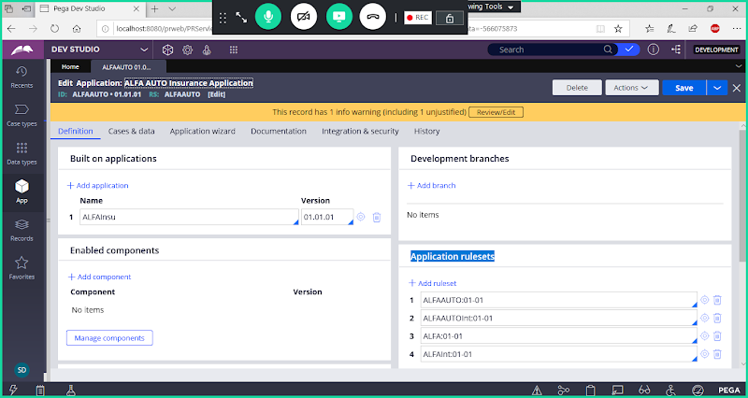

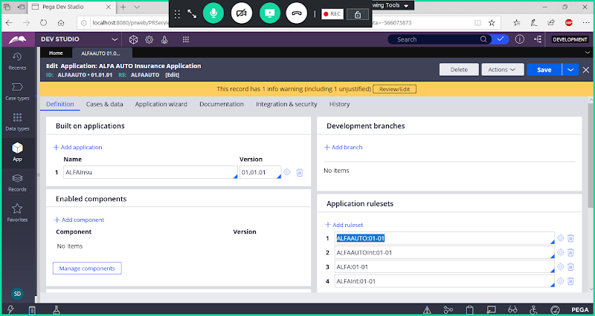

**Next to Ruleset Name Click on Circle:**

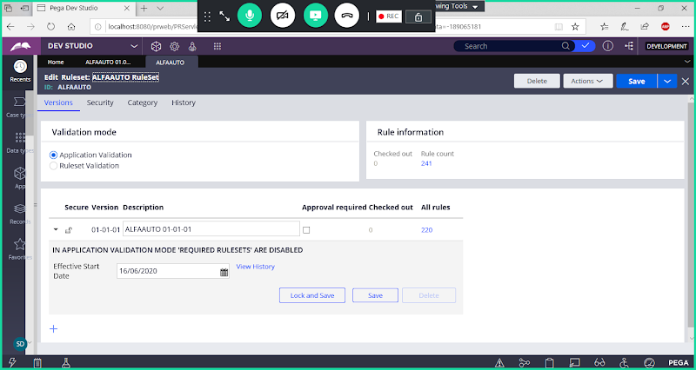

**Add a New Version for your Ruleset:**



**Click on Add a Row**

**Click on Create**

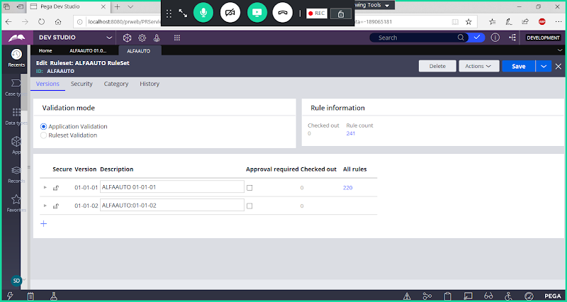

**Save Ruleset**

**After adding New Version we have to Lock Previous Version ( 01-01-01)**

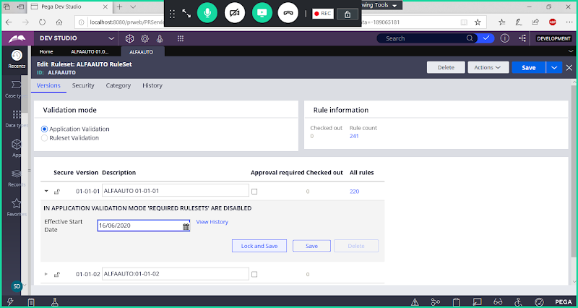

**Click on Lock & Save**

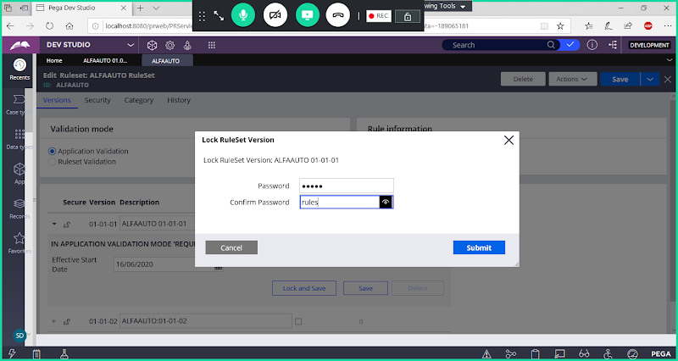

**Password: rules**

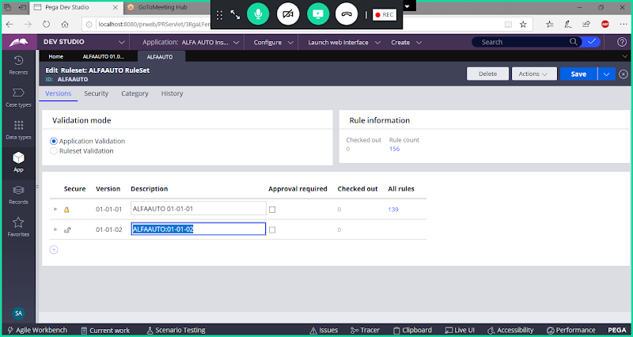

**Save the Ruleset:**

**Now any New Rule we are adding in the application will be saved under new Version.**

* **In Locked Version we cannot add any new Rules.**
* **In Locked Version we cannot update the Existing Rule in the Same Version**
* **To Do any changes to the Rule in Locked Version, Move the Rule to Latest Ruleset Version to modify the Rule.**
* **If we have same rule in Multiple Versions, then it will pick the latest version rule.**

**How to Secure a Ruleset:**

**Open Ruleset Form:**

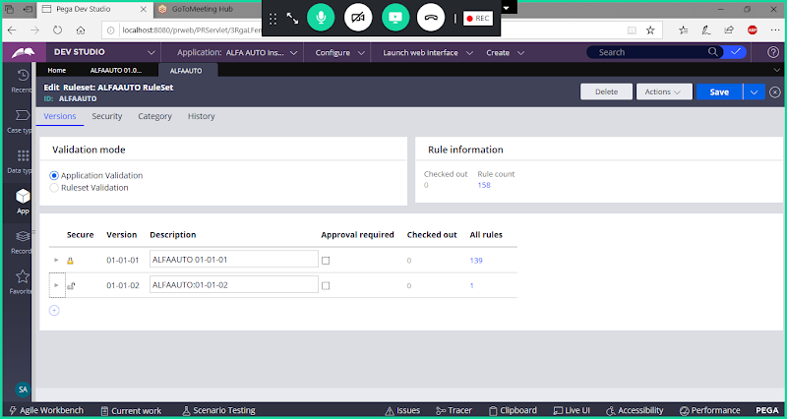

**Go to Security Tab:**

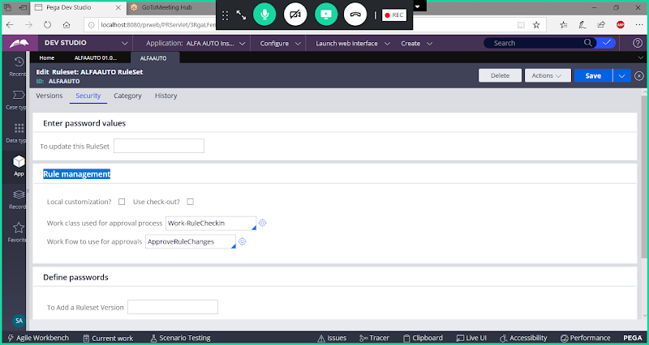

**Check Box: Use Check-out ( Disabled by default)**

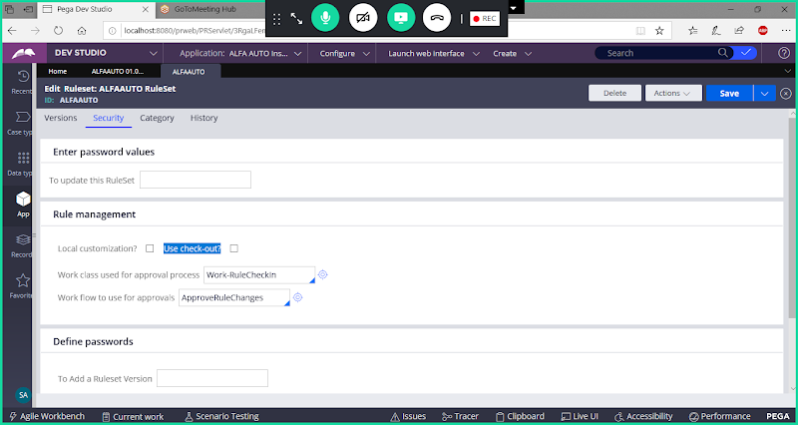

**Enable Use Check-out Option:**

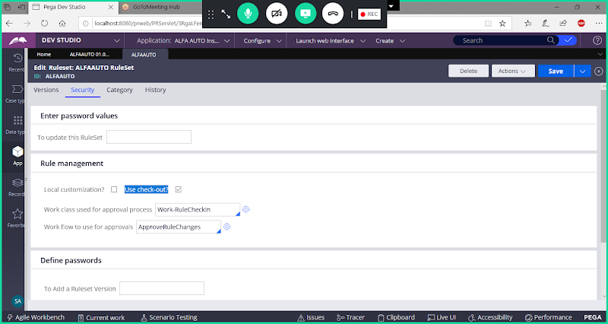

**Save Ruleset**

**After Ruleset Security is enabled you can see below options for the Rules:**

**Check In and Check Out:  This feature prevents parallel Development.**

**Private-Edit:**

**If the Rule is in Locked Version, when you open the rule you will get the option as Private Edit.**

**- If Operator is Getting Private edit & Rule is in Locked Version then Developer has to use Saveas option to edit the rule/Private Edit to edit the Rule. If you continue doing Private edit the rule will be moved to latest ruleset version**

**- If One Operator is working on any Rule & for other operators it will show option as Private edit**

**Check-out: Lock the Rule, Modify & Save (rule is available for Editing)**

**The rule is available for the developer to modify. ( If Check out means the Rule is there under Latest Version)**

**When Operator Click on Check out( Locking the Rule) option, the rule will be locked by that Operator.**

**Check-in:  Unlock the Rule/Check in our Changes**

**Once operator is done with modifications he need to save the rule & Check in ( Releasing the Lock). After Check in Only other Operators can see the Changes/Modifications done for that rule.**

**What Happens when u click on check-out?**

**When we Check Out any Rule, Your Rule will go to Personal Ruleset. ( It is a Virtual Ruleset, For every developer they will have their own personal Ruleset. User Operator Id is ur Persoanl Name: ex: Admin@ALFA, ALFA1)**

**======**

**How Work Object Locking will happen?**

* **When an Operator tries to open a case, Process commander looks on a Lock Table: pr_sys_locks**
* **If an entry is available in the table, means that a case is already been worked by someone.**
* **If there is no entry then entry will be inserted in the name of current operator. i.e. Lock is acquired on the current operator name.**

**========**